**How Can I win My March Madness Pool Next Year?**

*American Statistical Association Data Visualization Poster Competition Project (April 2018)*

**Background :**

People typically use ranking as one of the guidance’s to pick their bets in the pools. We wanted to see how well ranking as well as other factors can forecast for NCAA Tournament (aka March Madness) success in the knock out system.

**Question Asked:**

1. How the magnitude of difference in ranking difference between the teams can impact the outcome?
2. Dose the ranking matters in the same way for all rounds of tournament?
3. Does the average age of players in a team impact the outcome? That is if the team with younger player has better chance of winning?

**Methods:**

We extracted publicly available ranking data of the previous 2017 NCAA games data of 64 teams including over 800 players. The number of player ranged from 9 to 18 in a team with the age range of ~19 to 22 years.

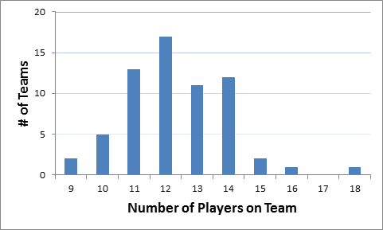

The NCAA Men’s Basketball Tournament 64 teams start a **knock-out system**. In knock-out system is such that in each round all teams are matched up with another team and the winning team moves to the next round. The losing team takes a bus or flight back home.

Our data is based on the games that those 64 teams played in various rounds. These teams are divided up into 4 regions. The 16 teams in each region have their own ranking, a seed ranging from 1 to 16. This ranking is based on the NCAA Division 1 Basketball Ball committee.

**First Round:** overall 32 games are played across 64 teams. In this round, the first ranked team plays against the lowest ranked team, number 16. The second ranked team plays against 15, and so forth. As a result, in each region a game is played between a higher ranked team (“Favorite”) against the lower ranked team (“Underdog”). The winning teams make it to the next round.

**Second and Later Rounds:** overall 31 games are played (16 in second round; 8 in third round; and so on until the final championship game) where winning team moves to next round.

**Results:**

We categorized the differences in ranking of two teams in 3 categories (1-5 points; 6-10 points; 11-15 points) for each game and examined its impact on winning overall and by tournament rounds as well as average team age.

Summary of winning by “Favorites” and “Underdogs” by the ranking difference

|  |  |  |  |
| --- | --- | --- | --- |
| Ranking Difference | Number of Games Played* | Favorite Winning | Underdog Winning |
| 1-5 Points | 30 | 67% | 33% |
| 6-10 Points | 20 | 80% | 20% |
| 11-15 Points | 12 | 100% | 0% |
| **Total** | **62** | **77%** | **23%** |

Favorite: Higher ranking team; Underdog: Lower ranking team

*one final game was not included due to same ranking of the two team, i.e. number one.

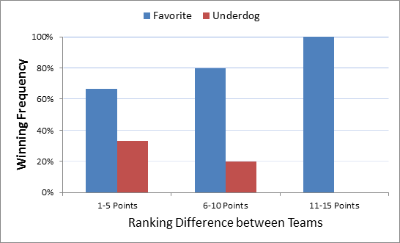

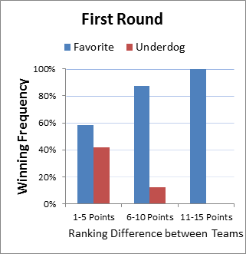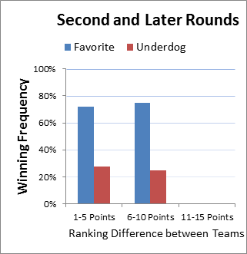

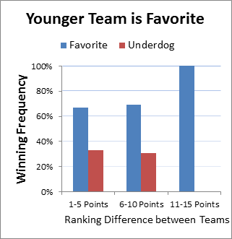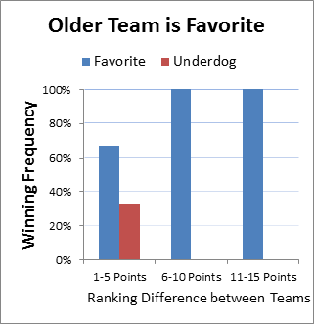

**What Should You Do Next Year?**

Next year, if you want to win your March Madness pool, make sure that:

* You are more likely to choose the “Favorite” over the underdog (77% empirical chance to get the right answer),
* Avoid choosing underdogs that are ranked more than 10 points below the “Favorite” (100% empirical chance to get the right answer)
* If the ranking is over 5 points, give some credit to the team that has those experienced seniors that are ready to run for the NBA draft (100% empirical chance to get the right answer),
* In the first round of the tournament, be more likely to stick with the “Favorite” that is more than 5 points ahead of the underdog (95% empirical chance to get the right answer), but you can bet on some of the small upsets (Yes, that number 8 can beat the number 9).
* Don’t choose the Bulldogs over the Ducks, because you are a dog-lover (We have not tested this in this poster as we did not have any data points)

**Questions Answered:**

1. The magnitude of ranking difference: It is a strong and consistent predictor of winning.
2. The round in the tournament: It appears the ranking would be valuable in the initial rounds, but would be less important when the tournament move beyond the initial rounds.
3. Age of the team: Age factor could contribute to a team’s winning percentage, beyond one team’s ranking.
   1. Younger team (lower average age of player than opponent) has better chance to win.
   2. Relatively speaking, the “Favorite” older team has better chance of winning as compared to “Favorite” younger team. It could be the older team would have more experience that could be valuable in the final minutes in a back and forth game.

**Source of data:**

<https://www.spreadsheetsports.com/2017-ncaa-tournament-data/>